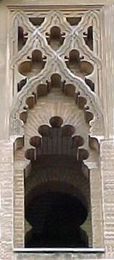

Summer Study Abroad

SPAIN 2017

Explore Segovia!

2017 DeSales SUMMER

LANGUAGE PROGRAM

May 29 - June 27, 2017

at the Center of Hispanic

Studies of Segovia

with

City Excursions and Travel!

**Open to all LVAIC students.**

**Intermediate and Advanced**

**Students of Spanish**

3 Credit Courses: Spanish Language, Spanish Art History (in English or Spanish), and Literature.

[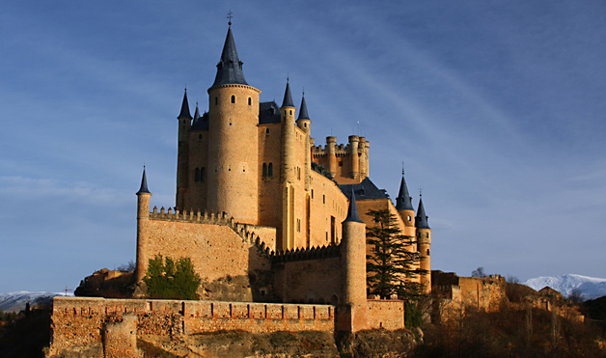](http://www.google.com/url?sa=i&rct=j&q=&esrc=s&frm=1&source=images&cd=&cad=rja&docid=jnx3gALAR_O9zM&tbnid=MyN5_n6tT7x6zM:&ved=0CAUQjRw&url=http://sites.psu.edu/kef5274/2012/11/16/segovia-spain/&ei=AJF6Us2ePIXNsQS-soDACA&bvm=bv.55980276,d.cWc&psig=AFQjCNHyBrix42SMadPgoCuiMXLIYsO7Ag&ust=1383850600347511)

[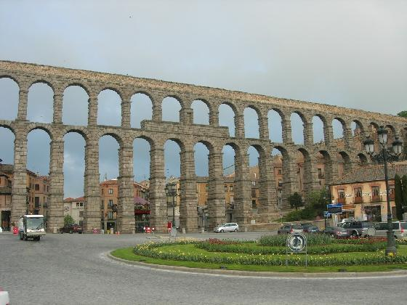](http://www.google.com/url?sa=i&rct=j&q=&esrc=s&frm=1&source=images&cd=&cad=rja&docid=YrR_MUbGIuZ4pM&tbnid=I1X1jGNeIUCVxM:&ved=0CAUQjRw&url=http://maxwellfite.blogspot.com/&ei=OZF6UtrpDIPLsAT_rIKoDg&bvm=bv.55980276,d.cWc&psig=AFQjCNHyBrix42SMadPgoCuiMXLIYsO7Ag&ust=1383850600347511)

For more information**,** call or email the Program Director:

**Dr. Angelica Silva,** DeSales University

**610-282-1100 ext. 1238 - email: *as07@desales.edu***